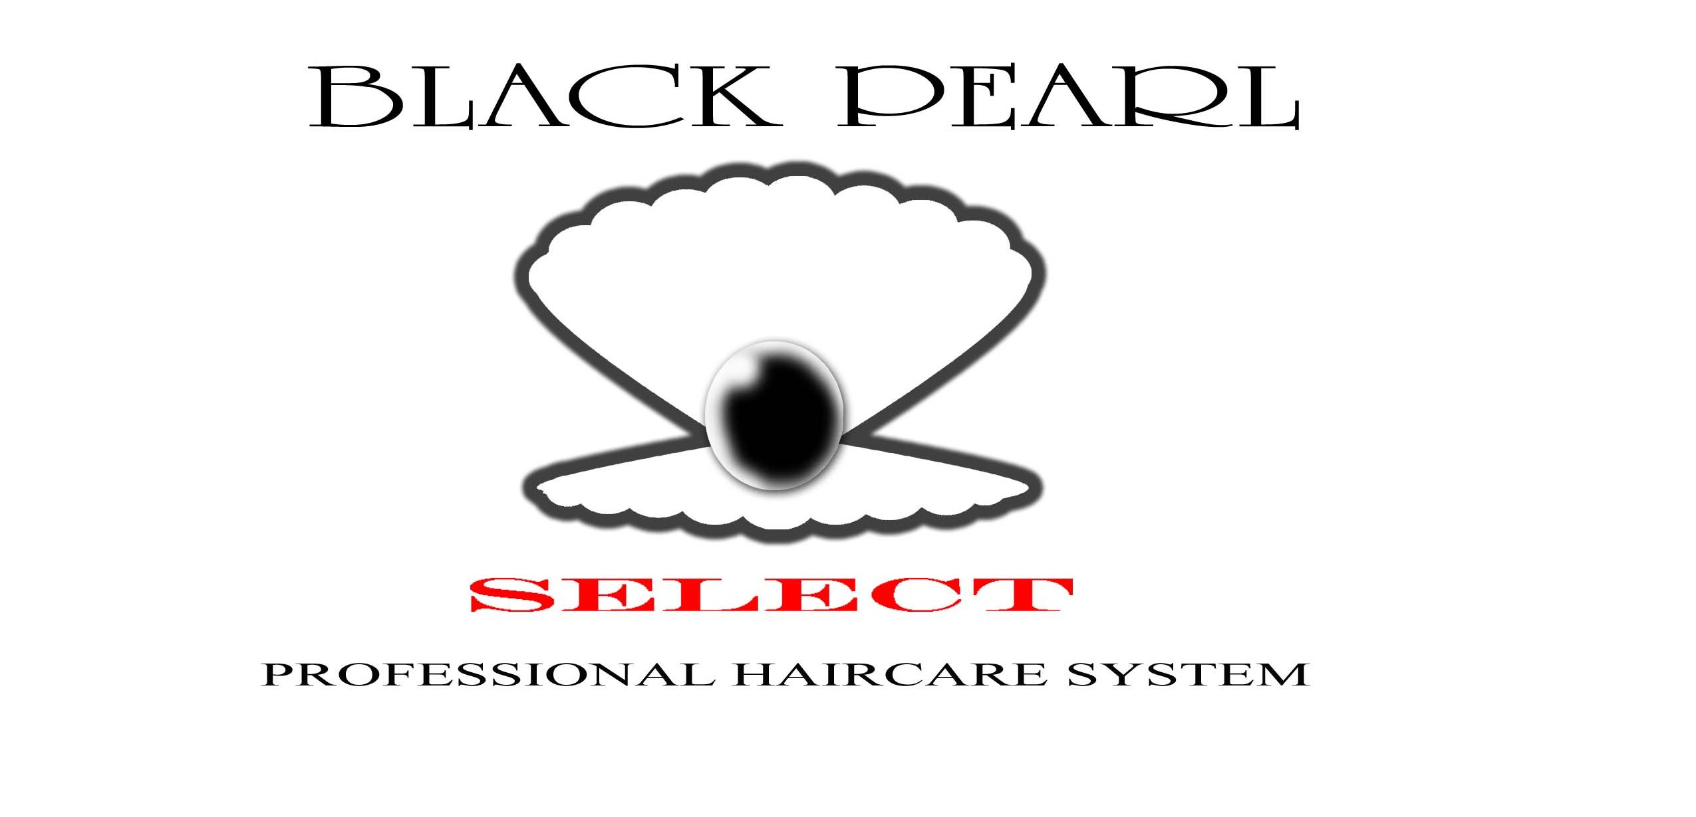
COMEDY LUAU BBQ COOK-OFF APPLICATION FORM

Highly anticipated, highly requested. All BBQ grillers that feel they have 'something special' in the grilling department are invited to the BBQ Cook Off challenge. The entrance fee is $50 and up to a three-man staff is permitted. Grillers must bring all gear and equipment and be ready to start from scratch. Must arrive by 6:30a to set up and start. Judging will be throughout as meat becomes ready. Final judging ends at 2:00pm. First, second, and third place trophies will be awarded along with an opportunity to showcase their flavors at the Black pearl select salons on a Saturday designated by the owner. Donation may be accepted during that time. All teams will receive certificates of participation.

COOK-OFF RULES: No pre-cooked meat, no commercial grills or equipment or utensils, cannot give meat away. Only allow enough meat for judging. Any remaining meat must be packed away to take back with you.
EVENT DATE IS SATURDAY, JULY 11, 2009
PLEASE PRINT AND RETURN WITH BBQ COOK-OFF FEE
(Deadline is Wednesday, July 8, 2009 postmarked)

Name(s) _________________________________________________

Address_______________________________________________________

Phone_________________________________________________________

Email_________________________________________________________

Amount enclosed $_____________

Make Check/Money Order Payable to: Black Pearl Select – Comedy Luau 2009

Complete this portion and mail to:
Black Pearl Select Salons
2908 Meridian Street, Suite A
Huntsville, AL 35811

An email confirmation will be sent upon receipt

